**Analog Electronics (Theory and Lab)**

**Design Objective:**

Design a circuit to control the temperature of an iron box. You can use a RTD as a sensing element. You may choose PT100 or similar RTDs. The circuit needs to make sure that the temperature is within ±5% of the set values. The temperature is set by using a potentiometer.

**Design Procedure and Component Selection:**

First I select a temperature range for operation: 100°C to 250°C

This range is considered since all the ironing temperature lies in this range with the most used cotton fabrics ironed around 180°C -220°C.Here is the exact values from Wikipedia.

|  |  |  |  |
| --- | --- | --- | --- |
| **Textile** | **Temperature[**[***citation needed***](https://en.wikipedia.org/wiki/Wikipedia:Citation_needed)**]** | **Temperature**[[2]](https://en.wikipedia.org/wiki/Ironing#cite_note-Ullmann-2) | **Dot mark** |
| [Toile](https://en.wikipedia.org/wiki/Toile) | 240 °C |  |  |
| [Triacetate](https://en.wikipedia.org/wiki/Triacetate) ("Estron", "Silene", "Tricell") | 200 °C | 220–250 °C |  |
| [Cotton](https://en.wikipedia.org/wiki/Cotton) | 204 °C / 400 °F | 180–220 °C | * * * [[9]](https://en.wikipedia.org/wiki/Ironing#cite_note-ullapopken_pflegefibel-9) |
| [Linen](https://en.wikipedia.org/wiki/Linen) (flax) | 230 °C / 445 °F | 215–240 °C | * * * [[9]](https://en.wikipedia.org/wiki/Ironing#cite_note-ullapopken_pflegefibel-9) |
| [Viscose](https://en.wikipedia.org/wiki/Viscose)/Rayon | 190 °C | 150–180 °C | * * [[9]](https://en.wikipedia.org/wiki/Ironing#cite_note-ullapopken_pflegefibel-9) |
| [Wool](https://en.wikipedia.org/wiki/Wool) | 148 °C / 300 °F | 160–170 °C | * * [[10]](https://en.wikipedia.org/wiki/Ironing#cite_note-lanidor_care_instructions-10) |
| [Polyester](https://en.wikipedia.org/wiki/Polyester) | 148 °C / 300 °F |  | * [[9]](https://en.wikipedia.org/wiki/Ironing#cite_note-ullapopken_pflegefibel-9) |
| [Silk](https://en.wikipedia.org/wiki/Silk) | 148 °C / 300 °F | 140–165 °C | * [[10]](https://en.wikipedia.org/wiki/Ironing#cite_note-lanidor_care_instructions-10) |
| [SympaTex](https://en.wikipedia.org/wiki/SympaTex) |  |  | * [[9]](https://en.wikipedia.org/wiki/Ironing#cite_note-ullapopken_pflegefibel-9) |
| [Acetate](https://en.wikipedia.org/wiki/Acetate) ("Arnel", "Celco", "Dicel") | 143 °C | 180 °C | * [[10]](https://en.wikipedia.org/wiki/Ironing#cite_note-lanidor_care_instructions-10) |
| [Acrylic](https://en.wikipedia.org/wiki/Acrylic_fiber) | 135 °C | 180 °C |  |
| [Lycra/spandex](https://en.wikipedia.org/wiki/Spandex) | 135 °C |  |  |
| [Nylon](https://en.wikipedia.org/wiki/Nylon)-6 | 150 °C | 150 °C | * |
| [Nylon](https://en.wikipedia.org/wiki/Nylon)-66 | 170 °C | 180–220 °C | *** |
| **Dot mark** | | **Temperature** | |
| * | | < 110 °C | |
| * * | | < 150 °C | |
| * * * | | < 200 °C | |

I assume an error or variation of at most 5°C in the output since minimum of 5% in the variation is 5°C itself at 100°C.Thus I am also designing the bistable circuit for a hysteresis of 5°C neglecting the slope which will arise in voltage transfer characteristics due to the linear region of operation. The design is done without considering non-idealities like offset voltage, input bias current, slew rate etc. Thus the final output may slightly differ from the chosen temperature range. I am also assuming that a 30V dc power supply is available. Regardless to mention since all of the electronic components are temperature sensitive I need to isolate all the components except the heater and the temperature sensor.

Refer to the final circuit diagram for a clear picture from here.

**Temperature Sensor:**

I use PT100.

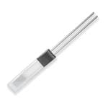

Here’s its datasheet: <https://www.ti.com/lit/an/sbaa275/sbaa275.pdf?ts=1640061199958&ref_url=https%253A%252F%252Fwww.google.com%252F#:~:text=Callendar%2DVan%20Dusen%20Equation&text=R0%20is%20the%20resistance%20of,PT100%20RTDs%2C%20the%20coefficients%20are%3A&text=A%20%3D%203.9083%20%E2%80%A2%2010%2D3,is%20displayed%20in%20Figure%201>.

From the datasheet after calculations, I find the resistances at the edges of the range.

R at 100°C = 138.506Ω.

R at 250°C = 194.01Ω.

It's modelled in LTspice using temperature as the variable. Observe that other components will not be affected by the temperature change since I used {t}.

**Comparator:**

For comparing, I use LT1016 an ultra-fast precision comparator.. It is Ultrafast (10ns typ) , Operates Off Single 5V Supply or ±5V , Complementary Output to TTL , Low Offset Voltage , No Minimum Input Slew Rate Requirement ,No Power Supply Current Spiking , Output Latch Capability . Substitutes like LM311,LM339 can also be used.

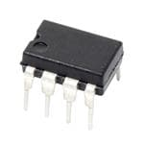

Here’s its datasheet: <https://www.analog.com/media/en/technical-documentation/data-sheets/lt1016.pdf>

**Power BJT :**

For on-off control as mentioned above, I use a BJT 2N3055.It's a power transistor with 15A 60V peak current and voltages. Substitutes like LM395,MJ2955 may also be used.

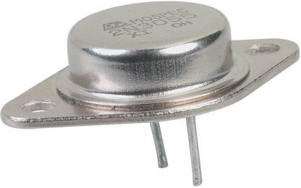

Here is the datasheet: <https://www.onsemi.com/pdf/datasheet/2n3055-d.pdf>

**Voltage Reference:**

For the circuit to work over a wide range of voltage supplies, the transducer (here PT100)-Bridge voltage must be stabilized. This can be done using LM329. It provides a constant value of 6.9V.

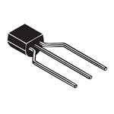

Here’s its datasheet: https://www.analog.com/media/en/technical-documentation/data-sheets/129329fd.pdf

I now set the values of resistors and diodes.

The purpose of R5 is to bias the sensor. I choose it as 470Ω±0.5%.

**Potentiometer:**

I now calibrate the potentiometer (designated as R2) as follows:

Current through the sensor=6.9/R. This ranges from 11.34mA to 10.39mA for the temperature range. From this the range of voltage at inverting terminals are obtained as 1.570V to 2.016V. Thus, current through R2 becomes (2.016-1.57)/R2.

I choose a standard 1kΩ±5% potentiometer.

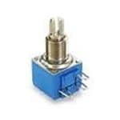

Here’s its datasheet:

<https://www.mouser.in/datasheet/2/54/8182_8586-2303030.pdf>

Thus current through it=0.446mA.

Thus R3=1.570/0.446m = 3.52kΩ. Choose R3= 3.52kΩ±0.5%.

R1 = (6.9-2.016)/0.446 = 10.95kΩ. Choose R1= 11kΩ±1%.

Since LTspice doesn’t offer a potentiometer symbol I created it as shown in the circuit diagram. It consists of 2 series resistors and an interconnector. Both their values are interconnected using the equation R7=R*val/100 and R8=R*(1-(val/100)) where R is the total potentiometer resistance and val is the percent of movement of potentiometer knob.

Choose R4=1.4kΩ±1% so that around 16mA current flows through it and thus gets divided among the other connected resistors. This ensures that around 5mA current flows through 6.9V reference and around 11mA current flows through PT100.

R6 acts as the pullup resistor used to bias the output of the comparator. It must be in few KΩ range so that the base of the BJT isn't overloaded. I choose it as 100kΩ±10%.

D2 ensures that V+ is within specified max limits. I use UMZ24K.



Here’s its datasheet:

http://rohmfs.rohm.com/en/products/databook/datasheet/discrete/diode/zener/umz24ktl-e.pdf

Lastly, I design the value of Rf the feedback resistor for hysteresis. Here I assume that the typical ON voltage of the BJT is around 0.9V-1V.

Then ΔVp=ΔVo*Rw/(Rw+Rf) where Rw is the equivalent resistance presented to Rf by the potentiometer wiper. With the wiper in the middle, Rw=(R1+R2/2)||(R3+R2/2)=2.98kΩ.

Using ΔVo=0.9V and ΔVo=14.15mV (how it comes is explained 2 para down) and substituting I get Rf=167kΩ. I use 167kΩ±0.5%.

Finally, I insert a diode D1 as protection against sudden change in inductor currents so that if any such sharp transients occur, they can flow through the diode D1. I choose 1N4148. 

Here’s its datasheet:

<https://www.mouser.in/datasheet/2/308/1N914_D-2309448.pdf>

Let’s now see the difference in resistance for 5°C hysteresis.

Temperature coefficient of resistance for PT100 is 3850ppm/K. From

R=R0(1+αT), I see that a max of 1.925Ω temperature difference is possible. This is helpful in testing without using temperature initially. For this, I find the voltage difference appearing across PT100 during hysteresis as:

V=(6.9/(R5+R)) *R, where R is the resistance of PT100 at a given temperature.

ΔV/ΔR = (6.95*R5/((R5+R) ^2))) *ΔR.

Thus, min ΔVp = 14.15mV.

The circuit operates as follows. As long as temperature is above setpoint I have Vn>Vp (where n and p denote the inverting and non-inverting terminals of the comparator), the bjt inside the comparator saturates keeping the 2N3055-heater combination off. If the temperature drops below the setpoint, then Vn<Vp and the transistor in the comparator is now cut-off, thus diverting the current supplied by R6 to the base of 2N3055 transistor. The latter then saturates, turning the heater fully ON. Introduction of Rf brings in hysteresis as mentioned above.

**Heater:**

# I use HP05-1/10-24.

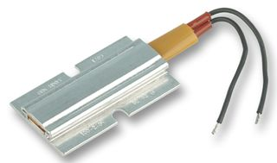

# This is modelled as a coil with 1mH inductance and 20Ω series resistance. Generally iron boxes use nichrome wire for heating which have very low temperature coefficient of resistance and inductance. Thus for simulation the chosen values are a good approximation. Also the assumption that the coil resistance is almost a constant under the range of temperature is also a good approximation.

**Circuit Diagram**

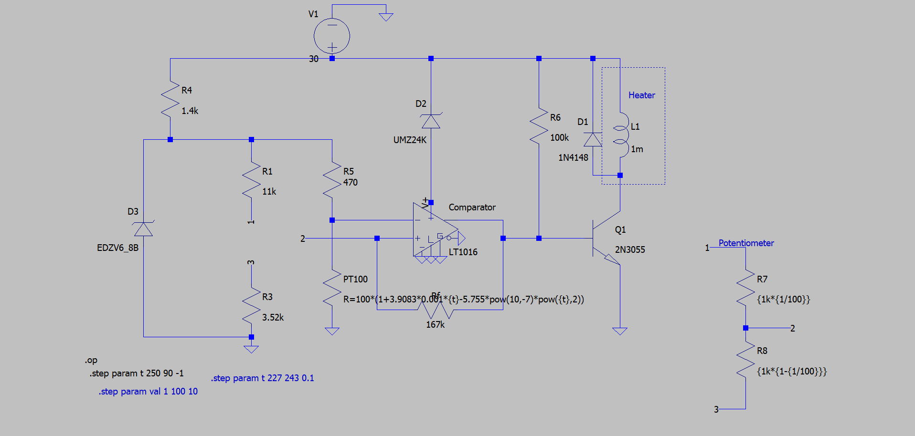

**Ltspice Simulations**

The plot shows the current through the heater coil as a function of temperature for different values of set temperatures.

Potentiometer set at near lowest temperature (expected to be 100°C):

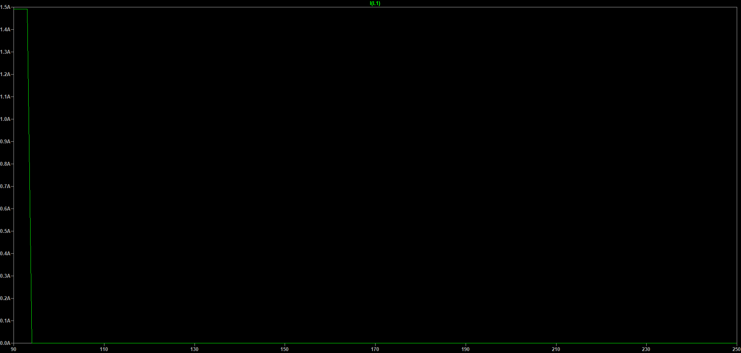

The shift occurs at 92.9°C to 94°C from ON to OFF.

ON current is 1.5A and OFF current around 532uA

Potentiometer at its middle:



The shift occurs at 159.7°C to 161°C from ON to OFF.

ON current is 1.5A and OFF current around 532uA

Potentiometer set at near highest temperature (expected to be 250°C):

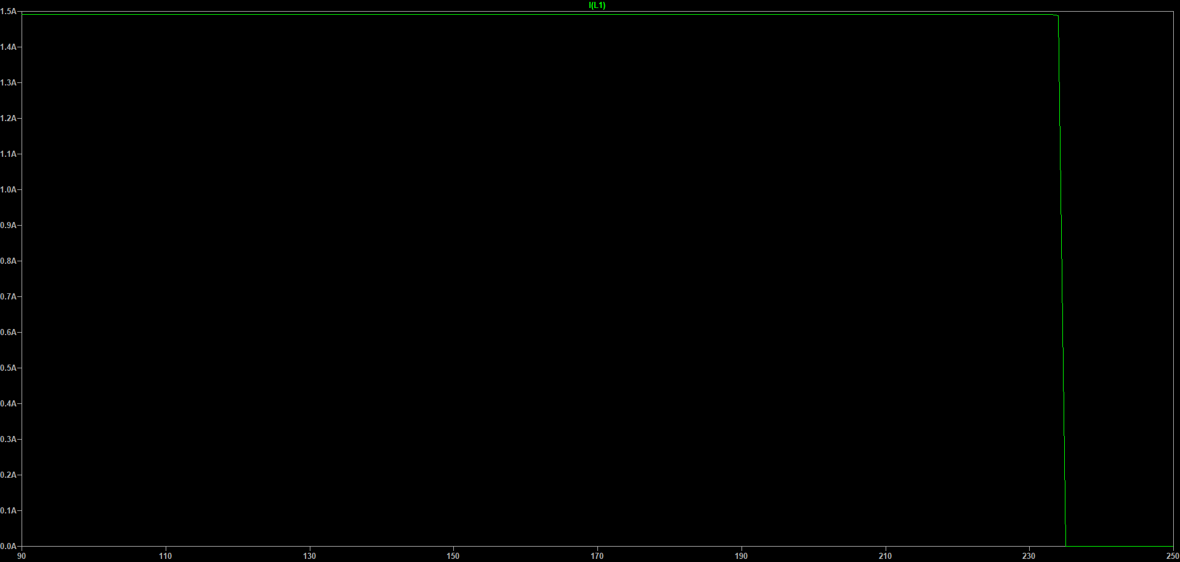

The shift occurs at 233°C to 236°C from ON to OFF.

ON current is 1.5A and OFF current around 532uA

Potentiometer set for cotton ironing at 180°C:

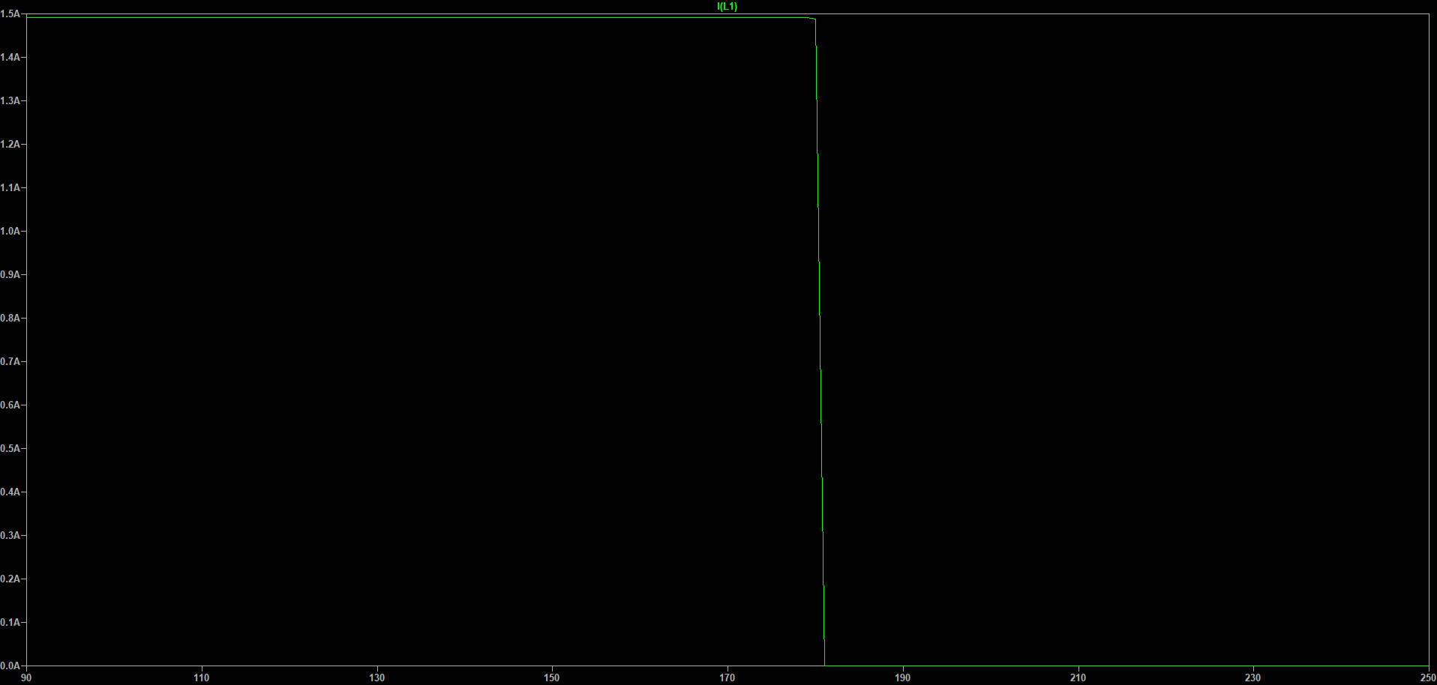

The shift occurs at 179.2°C to 181.2°C from ON to OFF.

ON current is 1.5A and OFF current around 532uA

Varying both Temperature and Potentiometer together:

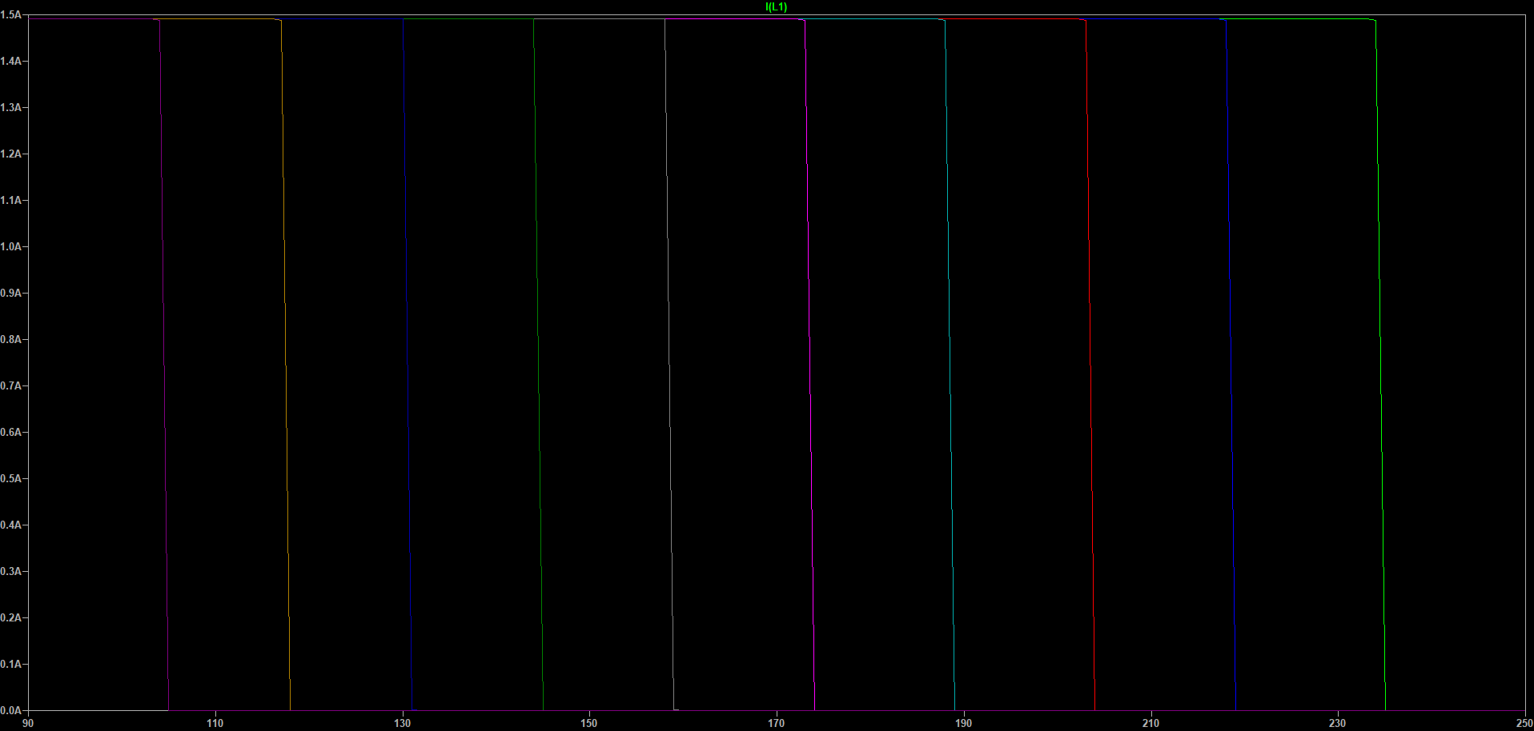

Since ltspice can't simulate temperature in reverse, for checking bistable behaviour of the circuit, I take the values of node voltages from resistances at comparator terminals, convert then to a sine wave and try to simulate. I simulate at 92̊C and 234°C. Since all the temperatures lie in between this we can safely assume that the hysteresis is valid for the entire range.

Circuit Diagram for bistable behaviour testing:

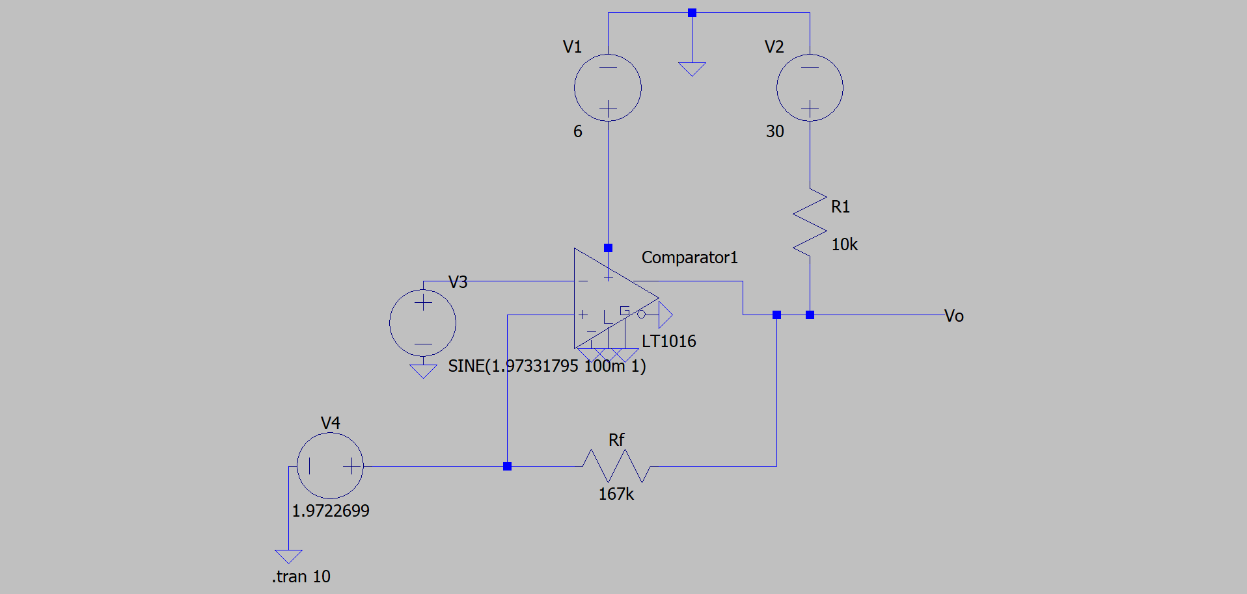

Results:

For 92°C:

At 87°C:

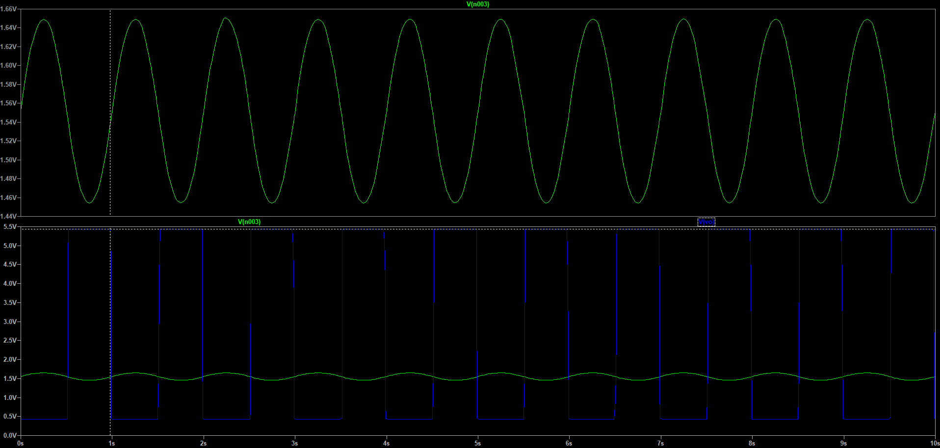

At 97°C:

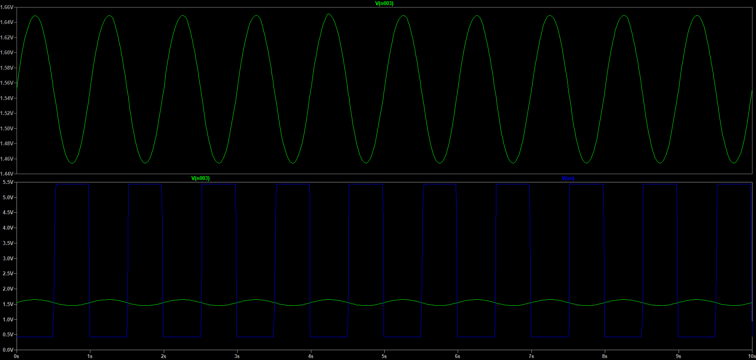

From these the ON-OFF and OFF-ON temperatures were calculated and then converted to their respective temperature ranges. In graph the blue one denotes it, green is sine wave.

ON-OFF happens at 93.79°C and OFF-ON at 89.41°C.

For 234°C:

At 229°C:

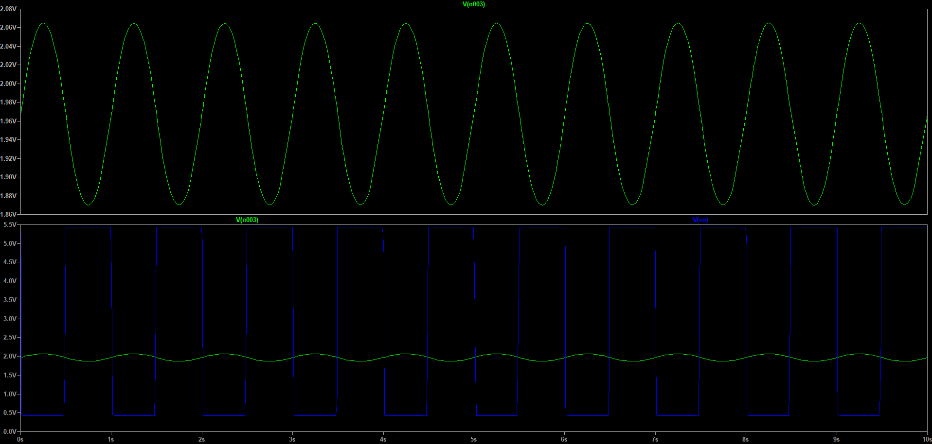

At 239°C:

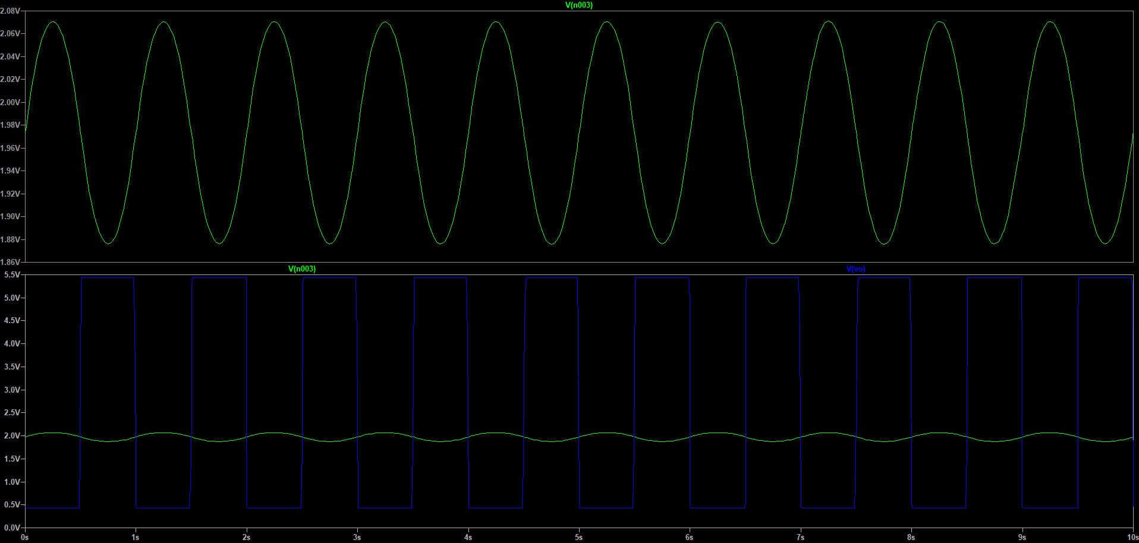

ON-OFF happens at 238.41°C and OFF-ON at 227°C.

I mention here that the change in voltages observed were very small of the order of mV. This is because the resistance change of PT100 is not too much per degree rise in temperature. Nevertheless the comparator can sense this.

**Results**

The simulations were done for different positions of potentiometer knob. It was observed that the On Off Currents remained the same with the On to Off change happening within 5°C for the entire temperature range with max error of around 4°C.These are exactly matching expectations. But the chosen temperature range shifted to 92°C to 234°C which is a small deviation from the expected 100°C to 250°C.This however does almost no harm since the On Off is unaffected. Further the potentiometer which in the external circuit can be calibrated accordingly in form of knob markings based on the exact industrial result which might differ from the LTspice results. The reason for the deviation might be the presence of unavoidable offset voltage (however small it may be). Other reasons like input bias currents might also contribute. This is obvious from the leftward shift.

Bistable behaviour is also working with the max hysteresis of 7°C and min of 1.79°C. These are also within the acceptable range.

Power delivered to load when ON=1.5^2*20=45W.

Power delivered to load when OFF= (532µ)^2*20=5.66µW.

Thus the heater selected is also fine. Also OFF power consumption is clearly negligible when compared to the ON state.

Thus the circuit seems fine for use.

**PCB DESIGN**

**KICAD Schematic:**

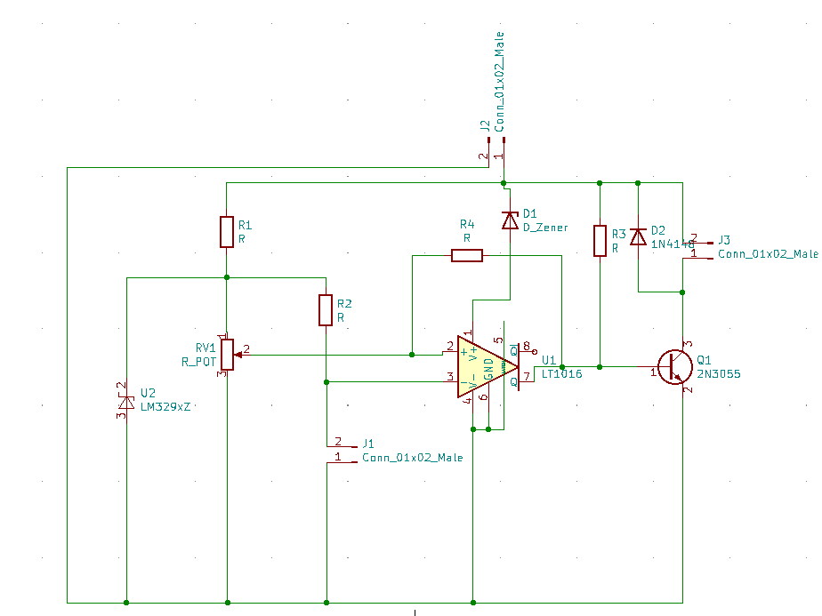

Connectors J1, J2 and J3 are 2 pin male connectors. J1 connects the RTD PT100 to the circuit, while J3 connects the heating element to the circuit.

These connectors are used to isolate the PCB from the high temperature region of the electric iron. Only the heating element and the RTD will experience high temperatures.

J2 contains the supply and ground terminals for the entire circuit.

**PCB Layout:**

The PCB is 85mm long and 40.6mm wide. Four mounting holes are placed at the four corners of the PCB. Mounting hole diameter in 2.1mm.

This is a two layer, 1.6mm thick PCB. It has a track width of 0.25mm with a clearance of 0.2mm.

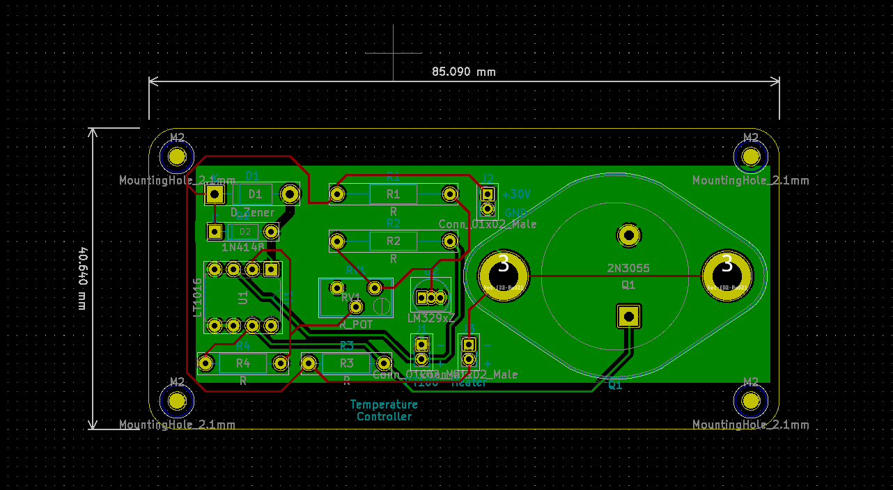

**Front copper:**

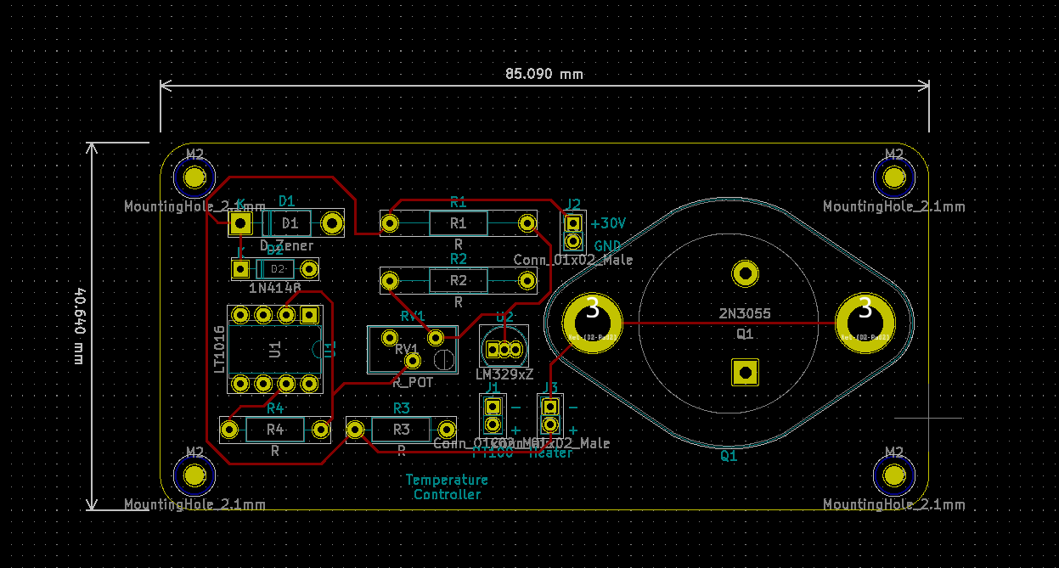

Red lines represent tracks on front copper of the PCB, connecting components.

**Back copper:**

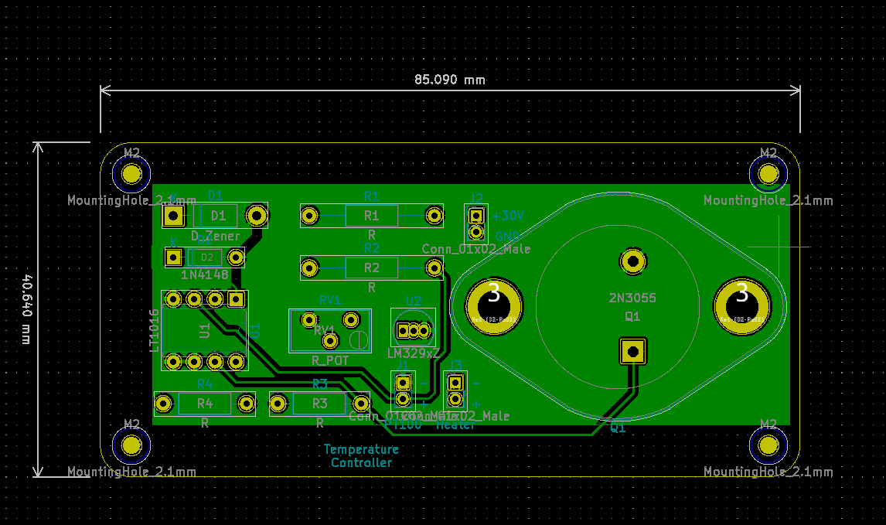

The green plane is a filled copper zone acting as the ground plane of the PCB. The green lines are tracks on the back copper of the PCB connecting components. Clearance of 0.2mm is provided between component pins and the ground plane for pins that are not connected to the ground. Also, clearance of 0.2mm is provided between ground plane and tracks.

**3D view:**

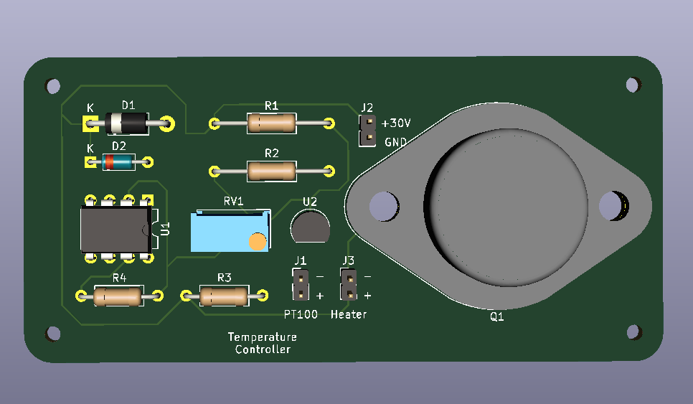

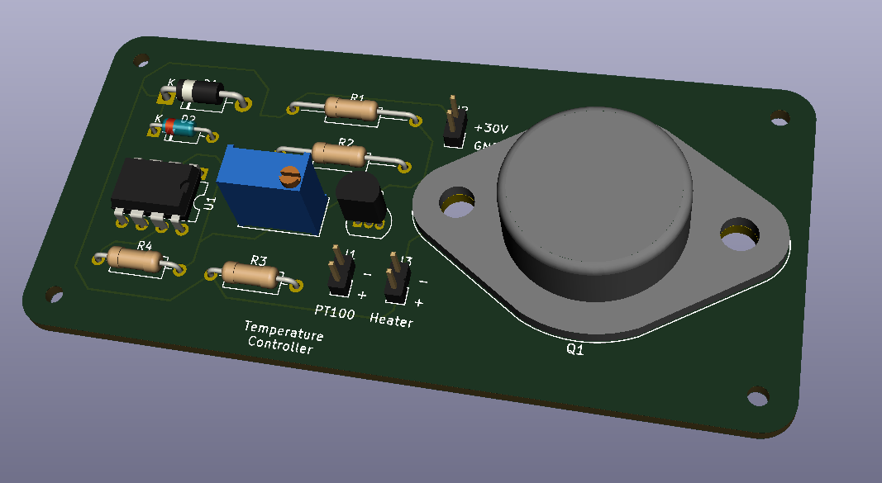

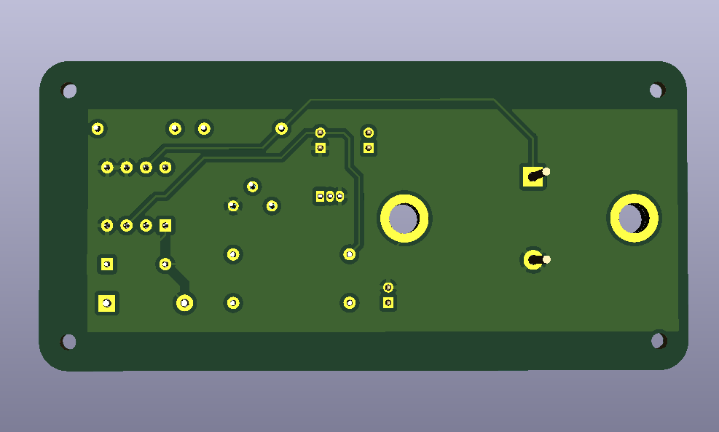

**References**

Some are mentioned throughout the report.

Others:

1. ti.com
2. Design with op amps and analog ICs Sergio Franco
3. youtube.com
4. forum.kicad.info
5. analog.com

By Nithin M

SC20B101